**YASHODHA R NAIK**

**1NT20IS416**

**BIG DATA LAB**

**show dbs**

admin 0.000GB

config 0.000GB

local 0.000GB

mydb 0.000GB

test 0.000GB

yashodha 0.000GB

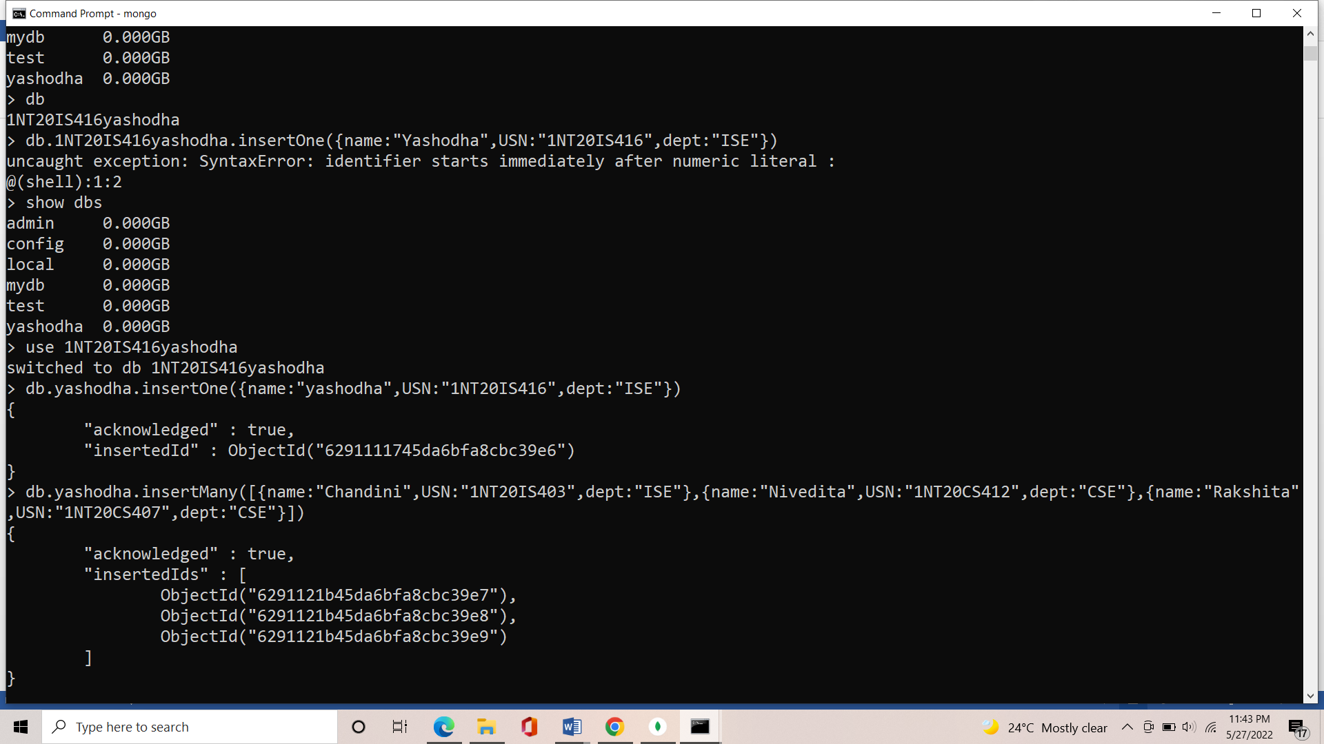

**CREATING DB**

> use 1NT20IS416yashodha

switched to db 1NT20IS416yashodha



**INSERT ONE COMMAND:**

db.yashodha.insertOne({name:"yashodha",USN:"1NT20IS416",dept:"ISE"})

{

"acknowledged" : true,

"insertedId" : ObjectId("6291111745da6bfa8cbc39e6")

}

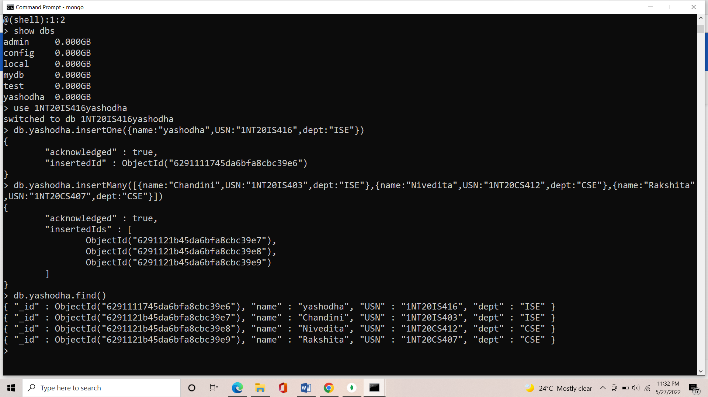

**INSERT MANY COMMANDS:**

db.yashodha.insertMany([{name:"Chandini",USN:"1NT20IS403",dept:"ISE"},{name:"Nivedita",USN:"1NT20CS412",dept:"CSE"},{name:"Rakshita",USN:"1NT20CS407",dept:"CSE"}])

{

"acknowledged" : true,

"insertedIds" : [

ObjectId("6291121b45da6bfa8cbc39e7"),

ObjectId("6291121b45da6bfa8cbc39e8"),

ObjectId("6291121b45da6bfa8cbc39e9")

]

}



**OUTPUT OF INSERTING COMMAND:**

> db.yashodha.find()

{ "_id" : ObjectId("6291111745da6bfa8cbc39e6"), "name" : "yashodha", "USN" : "1NT20IS416", "dept" : "ISE" }

{ "_id" : ObjectId("6291121b45da6bfa8cbc39e7"), "name" : "Chandini", "USN" : "1NT20IS403", "dept" : "ISE" }

{ "_id" : ObjectId("6291121b45da6bfa8cbc39e8"), "name" : "Nivedita", "USN" : "1NT20CS412", "dept" : "CSE" }

{ "_id" : ObjectId("6291121b45da6bfa8cbc39e9"), "name" : "Rakshita", "USN" : "1NT20CS407", "dept" : "CSE" }

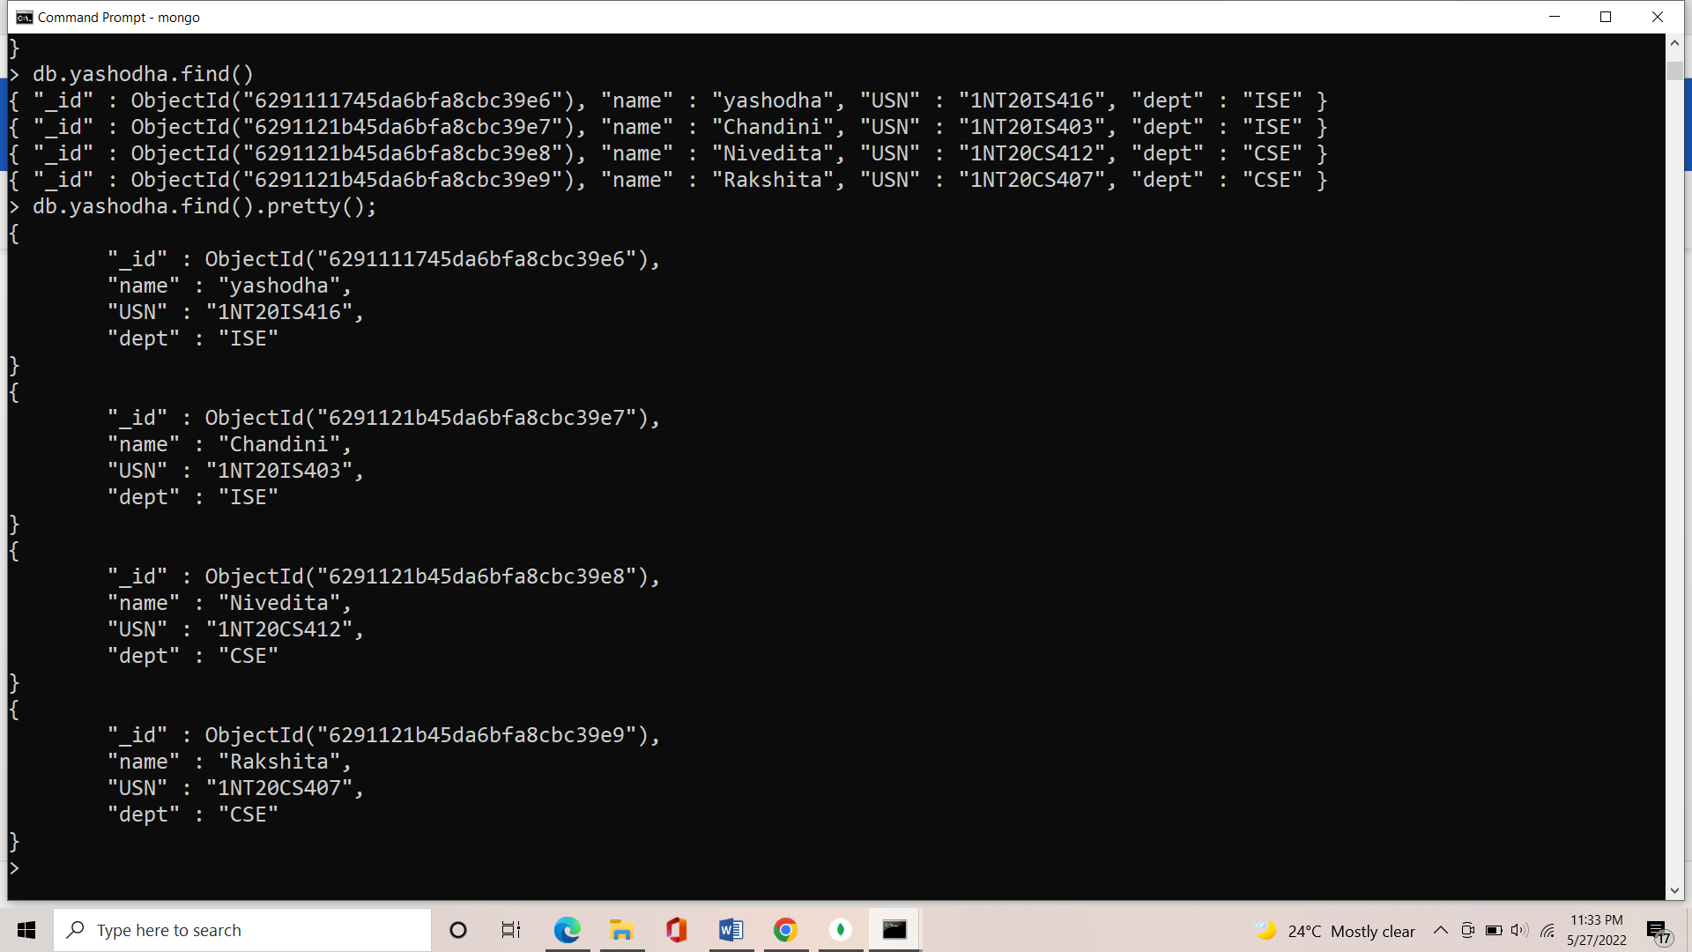

**OUTPUT USING PRETTY COMMAND:**

> db.yashodha.find().pretty();

{

"_id" : ObjectId("6291111745da6bfa8cbc39e6"),

"name" : "yashodha",

"USN" : "1NT20IS416",

"dept" : "ISE"

}

{

"_id" : ObjectId("6291121b45da6bfa8cbc39e7"),

"name" : "Chandini",

"USN" : "1NT20IS403",

"dept" : "ISE"

}

{

"_id" : ObjectId("6291121b45da6bfa8cbc39e8"),

"name" : "Nivedita",

"USN" : "1NT20CS412",

"dept" : "CSE"

}

{

"_id" : ObjectId("6291121b45da6bfa8cbc39e9"),

"name" : "Rakshita",

"USN" : "1NT20CS407",

"dept" : "CSE"

}



**UPDATE ONE AND UPDATE MANY COMMAND:**

> db.yashodha.updateOne({name:"Rakshita"},{$set:{name:"Chandana"}})

{ "acknowledged" : true, "matchedCount" : 1, "modifiedCount" : 1 }

> db.yashodha.find()

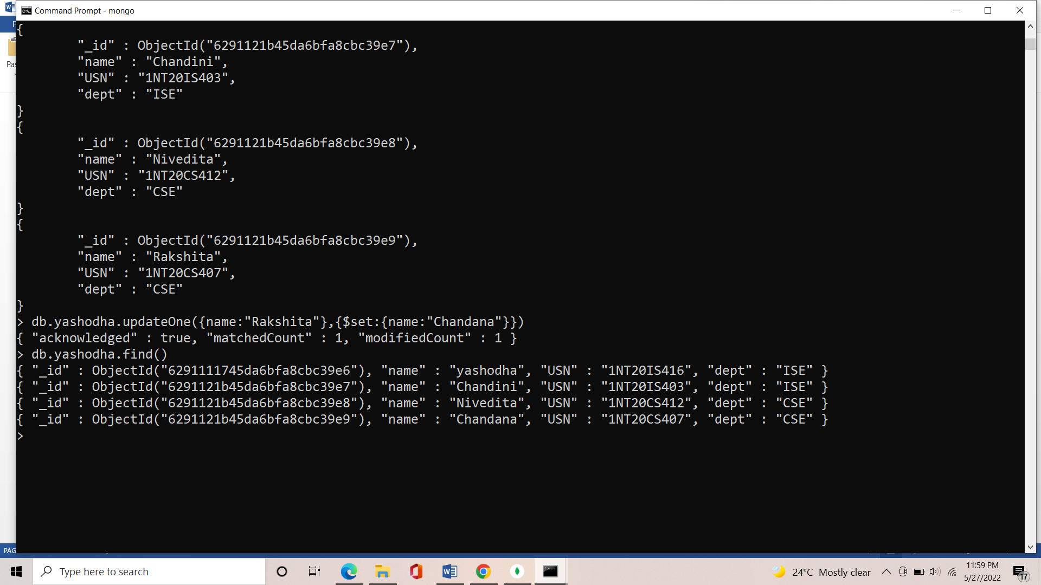

**OUTPUT OF UPDATEONE**

> db.yashodha.find()

{ "_id" : ObjectId("6291111745da6bfa8cbc39e6"), "name" : "yashodha", "USN" : "1NT20IS416", "dept" : "ISE" }

{ "_id" : ObjectId("6291121b45da6bfa8cbc39e7"), "name" : "Chandini", "USN" : "1NT20IS403", "dept" : "ISE" }

{ "_id" : ObjectId("6291121b45da6bfa8cbc39e8"), "name" : "Nivedita", "USN" : "1NT20CS412", "dept" : "CSE" }

{ "_id" : ObjectId("6291121b45da6bfa8cbc39e9"), "name" : "Chandana", "USN" : "1NT20CS407", "dept" : "CSE" }



**DELETE COMMAND:**

> db.yashodha.deleteMany({name:"yashodha"})

{ "acknowledged" : true, "deletedCount" : 1 }

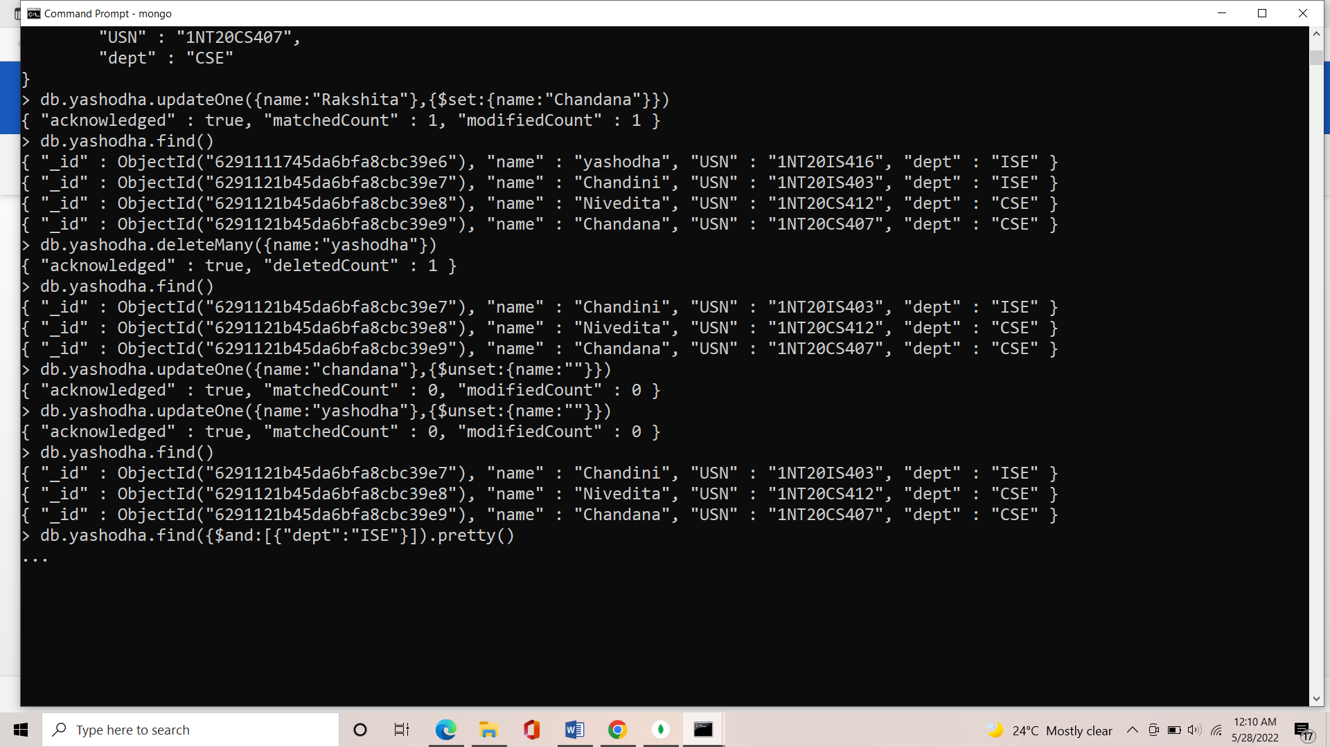

**OUTPUT OF DELETE COMMAND:**

> db.yashodha.find()

{ "_id" : ObjectId("6291121b45da6bfa8cbc39e7"), "name" : "Chandini", "USN" : "1NT20IS403", "dept" : "ISE" }

{ "_id" : ObjectId("6291121b45da6bfa8cbc39e8"), "name" : "Nivedita", "USN" : "1NT20CS412", "dept" : "CSE" }

{ "_id" : ObjectId("6291121b45da6bfa8cbc39e9"), "name" : "Chandana", "USN" : "1NT20CS407", "dept" : "CSE" }



**AGGREGATE COMANDS:**

db.yashodha.insertMany([{_id:0,name:"Pepperoni",size:"small",price:19,quantity:10,date:ISODate("2021-03-13T08:14:30Z")},{_id:1,name:"Pepperoni",size:"medium",price:20,quantity:20,date:ISODate("2021-03-13T09:13:24Z")},{_id:2,name:"Pepperoni",size:"large",price:21,quantity:30,date:ISODate("2021-03-17T09:22:12Z")},{_id:3,name:"Cheese",size:"small",price:12,quantity:15,date:ISODate("2021-03-13T11:21:39.736Z")},{_id:4,name:"Cheese",size:"medium",price:13,quantity:50,date:ISODate("2022-01-12T21:23:13.331Z")},{_id:5,name:"Cheese",size:"large",price:14,quantity:10,date:ISODate("2022-01-12T05:08:13Z")}])

{ "acknowledged" : true, "insertedIds" : [ 0, 1, 2, 3, 4, 5 ] }

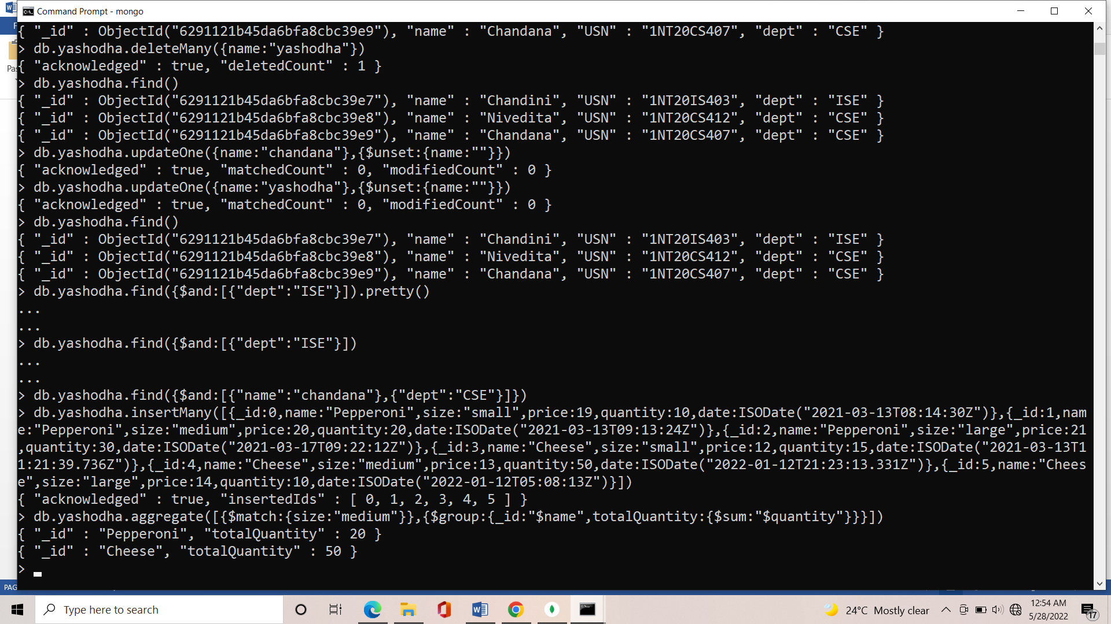

**OUTPUT OF AGGREGARE:**

db.yashodha.aggregate([{$match:{size:"medium"}},{$group:{_id:"$name",totalQuantity:{$sum:"$quantity"}}}])

{ "_id" : "Pepperoni", "totalQuantity" : 20 }

{ "_id" : "Cheese", "totalQuantity" : 50 }

